Workshop Maps
For the workshops you will need two sizes of maps:

A letter-sized 8 ½ X 11 (or similar) street maps, showing the meeting location and the exact area proposed for the walking audit. These will be a useful reference for the instructors, who are often performing a number of workshops in an area.
 | For the meeting, please provide a large-scale map (1”=200’ preferred) of the immediate study area – one copy (two preferred) of the map for each table of 6-8 people. Participants will mark on these maps as they develop ideas after their walking audit of the area. It is helpful if the streets are already labeled on the map. This will save time for the groups.  You should also supply a number of markers for each group. Make several colors available. Sharpies work well.  It is important that you not be stingy when it comes to the maps. Good maps (large, detailed, and colorful) are extremely important. Everyone comes back from the walk full of good ideas. | 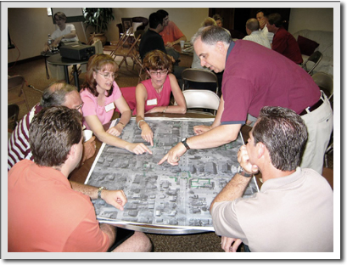  A table-sized map allows all group members to participate. The more ideas, the better.
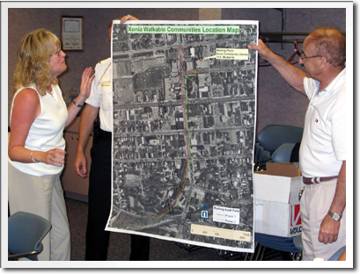  Large maps make ideas easier to see at presentation time. This map is of a good scale and quality, as well as being nicely labeled with street names and the walking route. |  | They will want to draw! Have two maps—a draft map, and a final presentation map—for each group

