The following checklist and completed local coordinator/workshop site application are a part of Metropolitan Washington Council of Government’s 2004 WCW Round 3 application. The first offers good tips on getting community buy-in for the workshops; the second demonstrates what steps a capable local coordinator may take in preparing for a workshop.

- Name and contact information for a local coordinator. Capable local coordinators are a key to overall success. They must be able to coordinate with a number of people and oversee many details related to the delivery of the workshops. This person has to have personal skills and abilities, and they must be able to commit to doing the legwork necessary to get people to come to the workshops. I will assist and support local coordinators.
- Identify a study area that you want to examine. The study area should be small enough to be walkable by the group in an hour and a half.
- Explain how you think a Walkable Communities workshop will help accomplish your community’s goals and objectives. Focus especially on the problems of the study area.
- Successful workshops have representatives from three key stakeholder groups: elected officials, professionals (both agency and non-agency), and citizen stakeholders (organized groups and individuals). Demonstrate some involvement from these groups, or explain how you plan to get their involvement.
- Letters from local community officials committing to host workshops do get noticed. This shows genuine interest and indicates that they may be more willing to commit to specific actions coming out of the workshops.
- Make special note of planning efforts that are upcoming or in progress that might get a boost from the workshops. Tell us how the Walkable Community Workshops will aid and abet these efforts.
- A commitment, formal or informal, to provide a $500 local match. This eases COG’s financial burden, and demonstrates seriousness.

Prepared by Michael Farrell, Metropolitan Washington Council of Governments
Revised 2/2005, NCBW
Information for a Walkable Communities Workshop in Oxon Hill

Name and contact information for a local coordinator.

(First Name) (Last Name)
(Address 1)
(Address 2)
(City) (State) (Zip)
(Phone)
(Email)

- Identify a study area that you want to examine. The study area should be small enough to be walkable by the group in an hour.

The study area is Oxon Hill Road (MD 414) from Indian Head Highway (MD 210) to Saint Barnabas Road – an area sometimes referred to as “Downtown Oxon Hill.” This 1.25 long corridor has a school, post office, library, garden apartments, church, three motels, a funeral home, three shopping centers, a Home Depot, office buildings, restaurants and fast food establishments, and many small businesses. The Oxon Hill Library is in the center of the study area and would be a good location for the workshop. (See the attached picture of the study area.)

- Explain how you think a Walkable Communities workshop will help accomplish your community’s goals and objectives. Focus especially on the problems of the study area.

A Walkable Communities workshop will help accomplish a major community goal of revitalizing this corridor and creating a livable/walkable community for those that live in the community and those that come into the corridor for shopping and business. With a school, a post office, a library, apartment complex, and numerous stores, office buildings, restaurants, and motels, walking in the community should be safe, convenient, and appealing. Over the years businesses have replaced homes and buildings have been built with little coordination or planning. A livable community vision is needed to transform this haphazard jumble of building and fast traffic into an area where people can walk comfortably between the many destinations in the corridor. Pedestrians now risk their lives crossing Oxon Hill Road, and motorists make unnecessary trips between multiple destinations in the corridor because it is such an unpleasant place for walking.

There are numerous problems in the study area:
- The posted speed on most of the this segment of Oxon Hill Road is 40 mph – much too fast for a walkable community.
- Traffic moves much faster than the posted speed.
- Many existing buildings are unattractive and in need of vitalization.
- Beautification of area with landscaping and trash removal is needed.
- Sidewalks need repair and widening.
- More pedestrian crosswalks are needed.
- Dangerous access to bus stops.

- Successful workshops have representatives from three key stakeholder groups: elected officials, professionals (both agency and non-agency), and citizen stakeholders (organized groups and individuals). Demonstrate some involvement from these groups, or explain how you plan to get their involvement.

Elected officials:
- Tony Knotts, Prince George’s County Council District 8 representative, is interested in improving pedestrian safety and creating more livable communities in his district. We contacted his office and they are interested in the workshop.
- State Senator Gloria Lawlah has been very helpful with bike/ped access in the past and her office said would likely participate in the workshop if it doesn’t conflict with the 2004 session of the General Assembly. We have worked with the three state delegates on related issues and can expect their participation.
- Jack Johnson, the Prince George’s County Executive, has given high priority to a Livable Communities Initiative. We have met with people from his office on related subjects and can expect participation from his office.

Professionals:
- Fred Shaffer, transportation planner with the Maryland Capital Area Park and Planning Commission, has offered his support.
- Michael Jackson, Director of Maryland Bicycle and Pedestrian Access in the Maryland Department of Transportation, has toured the area and offered his support.

Citizen Stakeholders:
- The Indian Head Highway Action Council (IHHAAC) is a coalition of a large number of stakeholder groups. IHHAAC is very active in community issues. Sarah Cavitt, president of IHHAAC, will ask the IHHAAC board of directors for their involvement.
- The Campaign to Reinvest in the Heart of Oxon Hill is a large citizen group committed to improving the study area. They have had annual events in the study area to bring attention to the opportunities of the area. Bonnie Bick is founder of the Campaign and said that the workshop will have good support and involvement from the Campaign.
- I have served on several focus groups and stakeholder panels with people that would like to be involved with the workshop.

- Letters from local community officials committing to host workshops do get noticed. This shows genuine interest and indicates that they may be more willing to commit to specific actions coming out of the workshops.

No letters at this time but we feel confident that we have support from our county council representative and will be able to provide letters of support and commitment.

- Make special note of planning efforts that are upcoming or in progress that might get a boost from the workshops. Tell us how the Walkable Community Workshops will aid and abet these efforts.
- The county executive Jack Johnson has a new initiative called “Gorgeous Prince Georges” that supports livable communities. The Walkable Workshop can help the County Executive and his Livable Community Initiative Committee find ways to create more walkable communities. Lessons learned studying the Oxon Hill Road study corridor can be applied to many similar situations in Prince George’s County.
- M-NCPPC is starting an update of the 1981 Subregion VII Master Plan-Henson Creek-South Potomac Master Plan. M-NCPPC has held one meeting with representatives of citizen groups to look at the Strengths / Weaknesses / Opportunities / Threats for this planning area. The study area for the workshop is along the northern edge of Subregion VII. Many ideas that come out of the workshop can be included in the new Master Plan.
- The study area is designated as a Regional Center by the 2002 Prince George’s County Approved General Plan. One goal of the Centers and Corridors of the Plan is to “Require pedestrian-oriented and transit-oriented design.” The workshop can help participants better understand “pedestrian-oriented and transit-oriented design.”
7. A commitment, formal or informal, to provide a $500 local match. This eases COG’s financial burden, and demonstrates seriousness.
Enough interest has already been expressed by community groups and individuals that I am confident we can provide the $500 local match.
Study Area for the Oxon Hill Road (MD 414) Walkable Community Workshop

Indian Head Highway MD 210
Livingston Road
Saint Barnabas Road
Capital Beltway I-95

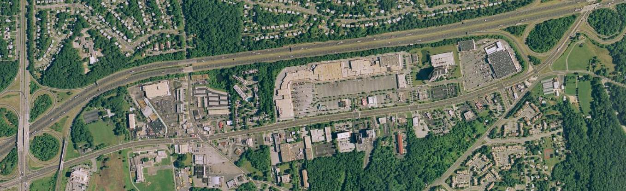
Library
School
Apartments
Post Office
The study area is 1.25 miles along Oxon Hill Road (MD 414) from MD 210 (Indian Head Highway) to Saint Barnabas Road. This corridor has three motels, a school, a post office, library, garden apartments, a church, a funeral home, three shopping, a Home Depot, office buildings, restaurants and fast food establishments and many small businesses.

Oxon Hill Road through the corridor is five and six lanes wide with a posted speed limit of 40 mph. There are several bus stops along the road. It is a corridor with sidewalks used by many pedestrians, but it is NOT a walkable community. The pedestrian in the photograph below had just run across the street from the apartments on the right. The road was designed and built for motorists, not pedestrians, transit riders or bicyclists. Many improvements can and should be made along the corridor to make it better for pedestrians, bicyclists, and transit-riders.

